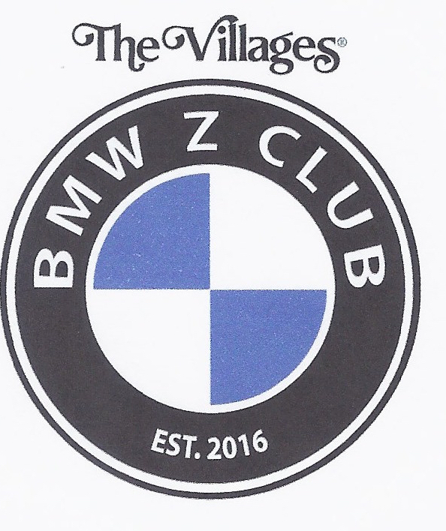
BMW Z CLUB
WWW. Villagesbmwzclub.com

September 05, 2019 Meeting Minutes

Hello fellow Zer's:

- The meeting was called to order at 7:00 pm.

- Treasury update: Current balance is $5,585.40

- Evelyn provided an update on membership. We have 164 members representing 89 cars.

- Well it’s official; the new name of the October gathering is the Annual “Z Fun Fest”. Thanks to the members for all there names and input.

- Bob Stolin presented an overview of upcoming rides;

- On September 16, 2019, members will be going to the Tail of The Dragoon in western North Carolina. The ride will take drivers first to Greenville-Spartanburg to view the BMW factory and track. Then drivers will head west to Deals Gap on the Tennessee/North Carolina border. Additional information is on the BMW Z Club website.

- On Thursday, October 24, 2019, we will celebrate the 3rd annual Z Fun Feast gathering at the Whispering Oaks Winery from 12:00 pm to 3:00 pm. There will be food, spirits, games, door prizes, 50/50 drawing, and live music for dancing! Please visit the BMW Z club website to sign up.

- On Friday November 01, 2019 members will be gathering at Lake Sumter Landing for a make-up date to showcase our cars on the square. Further information will be forthcoming as to times and meeting locations.

- On Wednesday November 06, 2019, BMW Ocala will again host us, for our 3rd BMW Z Club Party. The wonderful people from BMW Ocala provide us with a catered dinner, entertainment, and the opportunity to visit with technical people.

- On Thursday December 5, 2019, we celebrate the annual Holiday Party. This year’s gala will be at the Big Cypress recreation center. Entertainment will be provided by Rock Solid entertainment, and Little Bits catering will provide our dinner.

- On Thursday January 16, 2020, an overnight trip to St. Augustine FL. is being planned. Phil Burt is organizing this trip and took a poll of how many people are interested in this trip; plans are coming together for this outing.

- NOTE TO MEMBERS; Rides are being solicited, it’s very easy to get involved. All you need is an idea or suggestion, bring it to the attention of Bob Strolin and the Program Coordination Committee and they will assist you in becoming a ride captain.

- Technical Talk:
Ken has been in contact with Rob Cole (BMW Ocala) concerning the steering column issue with certain cars. BMW Ocala is addressing this issue with BMW Corporate and doing it’s best to accommodate effected owners and assist them the best they can. Corporate is reluctant to assist owners with financial aid in lieu of this becoming an all out recall and also the lack of replacement parts. In the mean time BMW Ocala will replace the steering columns for a cost of $3,287.16 including parts, labor and applicable club discounts.

- BMW Ocala is now scheduling Sunday oil changes for the discounted price of $49.95. Appointments are recommended.

- Just a reminder that logo apparel is available from the following merchants.
Custom Apparel in the Southern Trace Plaza on 466.
Company Apparel in Leesburg.
Gotta Get Your Name on in Spanish Springs.

- The Meeting was adjourned at 7:50 pm.

Respectfully submitted,
Phil Wenzel
Secretary
2019-09-05 Z Club MM.docx https://www.villagesbmwzclub.com/

