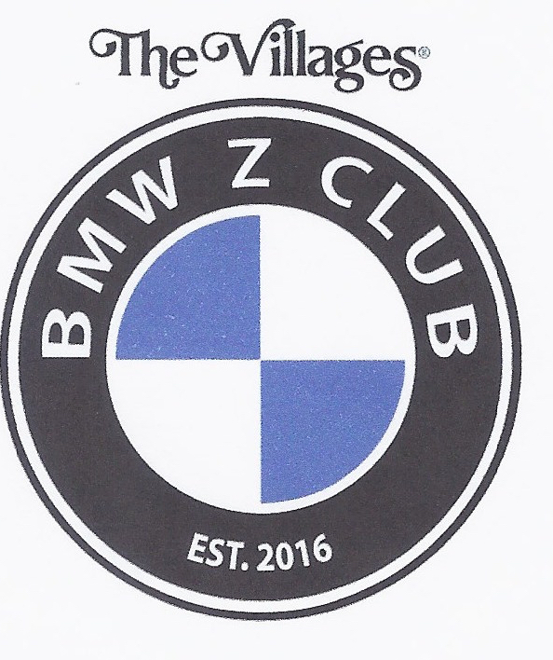
BMW Z CLUB
WWW. Villagesbmwzclub.com

October 06, 2021 Meeting Minutes

Hello fellow Zer's:

- The meeting was called to order and the National Anthem was played.

- Bob Basye provided the treasury update: Current balance is $ 4,530.27

- Audra Strolin provided updated membership update: We have 201 members representing 110 cars.
The membership extends a warm welcome to new members; Phil & Jeanne Martin and Bob Dixon.

- On Tuesday, Sept. 21,2021, The Villages BMW Z Club gave a $500 scholarship to Giovanni Vidales, a student in the Automotive Service Technician Program at Lake Technical College in Eustis.
Gio was chosen by his instructors because he has demonstrated dedication and commitment to the automotive repair program. Gio was very gracious in accepting the award and thanked the Club for their contribution to his education.
On hand for the presentation was Kimberly Frazier (Career & Technical Education Program Manager), Mark McKinney (Head Automotive Program Instructor), Diane Placek (Chairperson of the Charitable Giving Committee), Ed Evenski (Member of the Charitable Giving Committee), and Philip Burt.

- Bob Strolin presented an overview of rides and events in 2021;

- On October 08, 2021 your BMW Z Club will be the exclusive car club to exhibit our cars at the Brownwood Heritage Festival. Festival we be at Lake Sumter Landing and runs from 4:00 pm to 9:00 pm;
- On October 16, 2021 is the All-German car show at Harbor Hills CC;
- October 20, 2021: The “Z” Fun fest; We will be departing from the Rohan Recreation center. Gathering will take place at 11:00 am.
- December 10, 2021: the Annual Holiday Party. Please see the attached flyer for details;

- The Tail of the Dragon trip is in full swing. Ken Bornstein is organizing this trip. The dates are May 17-20 2022. Please visit the website for any new updates.

- NOTE: Please visit our website (https://www.villagesbmwzclub.com) to view information and sign up.

- NOTE TO MEMBERS: As you can see, we have many opportunities for other rides this year. It’s very easy to get involved. All you need is an idea or suggestion, bring it to the attention of Bob Strolin and the Program Coordination Committee and they will assist you in becoming a ride captain.

- Ken led a presentation of cars being able to communicate with each other and a look at the future BMW concept car.
- SAVE THE DATE: This year’s Holiday Party is set. We will be at the Big Cypress Recreation Center on December 10, 2021.

- Just a reminder that logo apparel is available from the following merchants.
Custom Apparel in the Southern Trace Plaza on 466.
Company Apparel in Leesburg.
Gotta Get Your Name on in Spanish Springs.

- The meeting closed at 8:15 pm. We thank you for coming.

Respectfully submitted,
Phil Wenzel, Secretary
2021-10-06 BMW Z Club MM.docx https://www.villagesbmwzclub.com/

